**The dream that failed**

**Nuclear power will not go away, but its role may never be more than marginal, says Oliver Morton**

Mar 10th 2012, *The Economist*

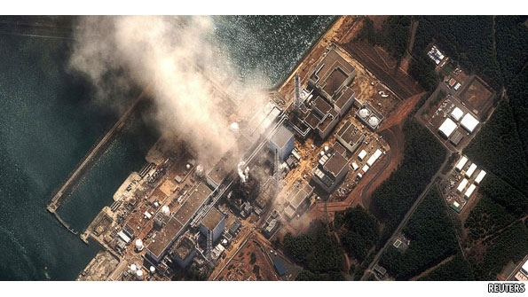

THE LIGHTS ARE not going off all over Japan, but the nuclear power plants are. Of the 54 reactors in those plants, with a combined capacity of 47.5 gigawatts (GW, a thousand megawatts), only two are operating today. A good dozen are unlikely ever to reopen: six at Fukushima Dai-ichi, which suffered a calamitous triple meltdown after an earthquake and tsunami on March 11th 2011 (pictured above), and others either too close to those reactors or now considered to be at risk of similar disaster. The rest, bar two, have shut down for maintenance or “stress tests” since the Fukushima accident and not yet been cleared to start up again. It is quite possible that none of them will get that permission before the two still running shut for scheduled maintenance by the end of April.

Japan has been using nuclear power since the 1960s. In 2010 it got 30% of its electricity from nuclear plants. This spring it may well join the ranks of the 150 nations currently muddling through with all their atoms unsplit. If the shutdown happens, it will not be permanent; a good number of the reactors now closed are likely to be reopened. But it could still have symbolic importance. To do without something hitherto seen as a necessity opens the mind to new possibilities. Japan had previously expected its use of nuclear energy to increase somewhat. Now the share of nuclear power in Japan’s energy mix is more likely to shrink, and it could just vanish altogether.

In most places any foretaste of that newly plausible future will barely be noticed. Bullet trains will flash on; flat panels will continue to shine; toilet seats will still warm up; factories will hum as they hummed before. Almost everywhere, when people reach for the light switches in their homes, the lights will come on. But not quite everywhere. In Futaba, Namie and Naraha the lights will stay off, and no factories will hum: not for want of power but for want of people. The 100,000 or so people that once lived in those and other towns close to the Fukushima Dai-ichi nuclear power plant have been evacuated. Some 30,000 may never return.

The triple meltdown at Fukushima a year ago was the world’s worst nuclear accident since the disaster at Chernobyl in the Ukraine in 1986. The damage extends far beyond a lost power station, a stricken operator (the Tokyo Electric Power Company, or Tepco) and an intense debate about the future of the nation’s nuclear power plants. It goes beyond the trillions of yen that will be needed for a decade-long effort to decommission the reactors and remove their wrecked cores, if indeed that proves possible, and the even greater sums that may be required for decontamination (which one expert, Tatsuhiko Kodama of Tokyo University, thinks could cost as much as ¥50 trillion, or $623 billion). It reaches deep into the lives of the displaced, and of those further afield who know they have been exposed to the fallout from the disaster. If it leads to a breakdown of the near-monopolies enjoyed by the country’s power companies, it will strike at some of the strongest complicities within the business-and-bureaucracy establishment.

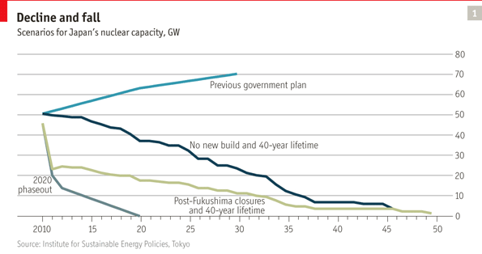

For parallels that do justice to the disaster, the Japanese find themselves reaching back to the second world war, otherwise seldom discussed: to the battle of Iwo Jima to describe the heroism of everyday workers abandoned by the officer class of company and government; to the imperial navy’s ill-judged infatuation with battleships, being likened to the establishment’s eagerness for ever more reactors; to the war as a whole as a measure of the sheer scale of the event. And, of course, to Hiroshima. Kiyoshi Kurokawa, an academic who is heading a commission investigating the disaster on behalf of the Japanese parliament, thinks that Fukushima has opened the way to a new scepticism about an ageing, dysfunctional status quo which could bring about a “third opening” of Japan comparable to the Meiji restoration and the American occupation after 1945.

To the public at large, the history of nuclear power is mostly a history of accidents: Three Mile Island, the 1979 partial meltdown of a nuclear reactor in Pennsylvania caused by a faulty valve, which led to a small release of radioactivity and the temporary evacuation of the area; Chernobyl, the 1986 disaster in the Ukraine in which a chain reaction got out of control and a reactor blew up, spreading radioactive material far and wide; and now Fukushima. But the field has been shaped more by broad economic and strategic trends than sudden shocks.

**The renaissance that wasn’t**

America’s nuclear bubble burst not after the accident at Three Mile Island but five years before it. The French nuclear-power programme, the most ambitious by far of the 1980s, continued largely undisturbed after Chernobyl, though other countries did pull back. The West’s “nuclear renaissance” much bruited over the past decade, in part as a response to climate change, fizzled out well before the roofs blew off Fukushima’s first, third and fourth reactor buildings. Today’s most dramatic nuclear expansion, in China, may be tempered by Fukushima, but it will not be halted.

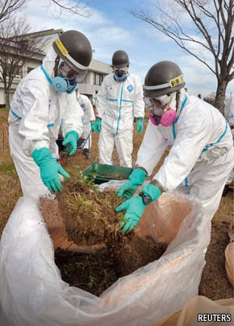For all that, Fukushima is a heavier blow than the previous two. Three Mile Island, disturbing as it was, released relatively little radioactivity and killed nobody. By causing nuclear safety to be tightened and buttressed with new institutions, it improved the industry’s reliability and profitability in America. Chernobyl was far worse, but it was caused by egregious operator error in a totalitarian regime incapable of the sort of transparency and accountability needed to ensure nuclear safety. It put paid to nuclear power in Italy and, for a while, Sweden, but in general it could be treated as an aberration of little direct relevance to the free world’s nuclear programmes. Poor regulation, an insufficient safety culture and human error (without which the Japanese tsunami’s effects might have been very different) are much more worrying when they strike in a technologically advanced democracy working with long-established reactor designs.

And if the blow is harder than the previous one, the recipient is less robust than it once was. In liberalised energy markets, building nuclear power plants is no longer a commercially feasible option: they are simply too expensive. Existing reactors can be run very profitably; their capacity can be upgraded and their lives extended. But forecast reductions in the capital costs of new reactors in America and Europe have failed to materialise and construction periods have lengthened. Nobody will now build one without some form of subsidy to finance it or a promise of a favourable deal for selling the electricity. And at the same time as the cost of new nuclear plants has become prohibitive in much of the world, worries about the dark side of nuclear power are resurgent, thanks to what is happening in Iran.

Barring major technological developments, nuclear power will continue to be a creature of politics not economics. This will limit the overall size of the industry

Nuclear proliferation has not gone as far or as fast as was feared in the 1960s. But it has proceeded, and it has done so hand in hand with nuclear power. There is only one state with nuclear weapons, Israel, that does not also have nuclear reactors to generate electricity. Only two non-European states with nuclear power stations, Japan and Mexico, have not at some point taken steps towards developing nuclear weapons, though most have pulled back before getting there.

If proliferation is one reason for treating the spread of nuclear power with caution, renewable energy is another. In 2010 the world’s installed renewable electricity capacity outstripped its nuclear capacity for the first time. That does not mean that the world got as much energy from renewables as from nuclear; reactors run at up to 93% of their stated capacity whereas wind and solar tend to be closer to 20%. Renewables are intermittent and take up a lot of space: generating a gigawatt of electricity with wind takes hundreds of square kilometres, whereas a nuclear reactor with the same capacity will fit into a large industrial building. That may limit the contribution renewables can ultimately make to energy supply. Unsubsidised renewables can currently displace fossil fuels only in special circumstances. But nuclear energy, which has received large subsidies in the past, has not displaced much in the way of fossil fuels either. And nuclear is getting more expensive whereas renewables are getting cheaper.

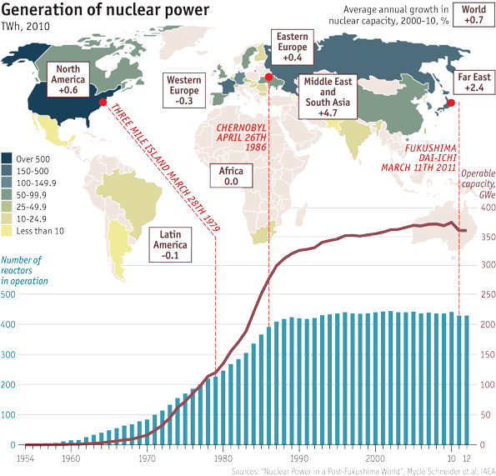

**Ulterior motives**

Nuclear power is not going to disappear. Germany, which in 2011 produced 5% of the world’s nuclear electricity, is abandoning it, as are some smaller countries. In Japan, and perhaps also in France, it looks likely to lose ground. But there will always be countries that find the technology attractive enough to make them willing to rearrange energy markets in its favour. If they have few indigenous energy resources, they may value, as Japan has done, the security offered by plants running on fuel that is cheap and easily stockpiled. Countries with existing nuclear capacity that do not share Germany’s deep nuclear unease or its enthusiasm for renewables may choose to buy new reactors to replace old ones, as Britain is seeking to do, to help with carbon emissions. Countries committed to proliferation, or at least interested in keeping that option open, will invest in nuclear, as may countries that find themselves with cash to spare and a wish to join what still looks like a technological premier league.

Besides, nuclear plants are long-lived things. Today’s reactors were mostly designed for a 40-year life, but many of them are being allowed to increase it to 60. New reactor designs aim for a span of 60 years that might be extended to 80. Given that it takes a decade or so to go from deciding to build a reactor to feeding the resulting electricity into a grid, reactors being planned now may still be working in the early 22nd century.

Barring major technological developments, though, nuclear power will continue to be a creature of politics not economics, with any growth a function of political will or a side-effect of protecting electrical utilities from open competition. This will limit the overall size of the industry. In 2010 nuclear power provided 13% of the world’s electricity, down from 18% in 1996. A pre-Fukushima scenario from the International Energy Agency that allowed for a little more action on carbon dioxide than has yet been taken predicted a rise of about 70% in nuclear capacity between 2010 and 2035; since other generating capacity will be growing too, that would keep nuclear’s 13% share roughly constant. A more guarded IEA scenario has rich countries building no new reactors other than those already under construction, other countries achieving only half their currently stated targets (which in nuclear matters are hardly ever met) and regulators being less generous in extending the life of existing plants. On that basis the installed capacity goes down a little, and the share of the electricity market drops to 7%.

Developing nuclear plants only at the behest of government will also make it harder for the industry to improve its safety culture. Where a government is convinced of the need for nuclear power, it may well be less likely to regulate it in the stringent, independent way the technology demands. Governments favour nuclear power by limiting the liability of its operators. If they did not, the industry would surely founder. But a different risk arises from the fact that governments can change their minds. Germany’s plants are being shut down in response to an accident its industry had nothing to do with. Being hostage to distant events thus adds a hard-to-calculate systemic risk to nuclear development.

The ability to split atoms and extract energy from them was one of the more remarkable scientific achievements of the 20th century, widely seen as world-changing. Intuitively one might expect such a scientific wonder either to sweep all before it or be renounced, rather than end up in a modest niche, at best stable, at worst dwindling. But if nuclear power teaches one lesson, it is to doubt all stories of technological determinism. It is not the essential nature of a technology that matters but its capacity to fit into the social, political and economic conditions of the day. If a technology fits into the human world in a way that gives it ever more scope for growth it can succeed beyond the dreams of its pioneers. The diesel engines that power the world’s shipping are an example; so are the artificial fertilisers that have allowed ever more people to be supplied by ever more productive farms, and the computers that make the world ever more hungry for yet more computing power.

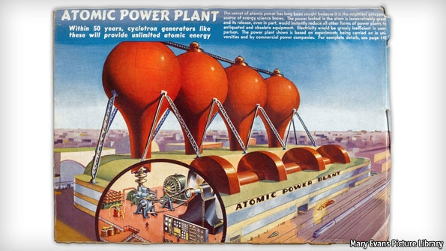*The way the future was*

There has been no such expansive setting for nuclear technologies. Their history has for the most part been one of concentration not expansion, of options being closed rather than opened. The history of nuclear weapons has been defined by avoiding their use and constraining the number of their possessors. Within countries they have concentrated power. As the American political commentator Gary Wills argues in his book, “Bomb Power”, the increased strategic role of the American presidency since 1945 stems in significant part from the way that nuclear weapons have redefined the role and power of the “commander-in-chief” (a term previously applied only in the context of the armed forces, not the nation as a whole) who has his finger on the button. In the energy world, nuclear has found its place nourishing technophile establishments like the “nuclear village” of vendors, bureaucrats, regulators and utilities in Japan whose lack of transparency and accountability did much to pave the way for Fukushima and the distrust that has followed in its wake. These political settings govern and limit what nuclear power can achieve.